**2017 PEW RESEARCH CENTER’S AMERICAN TRENDS PANEL**

**WAVE 30 DECEMBER 2017**

**DECEMBER 4-DECEMBER 18, 2017[1]**

**ASK ALL:**

LIFE1 Overall, are you satisfied or dissatisfied with the way things are going IN YOUR LIFE today?

1 Very satisfied

2 Mostly satisfied

3 Mostly dissatisfied

4 Very dissatisfied

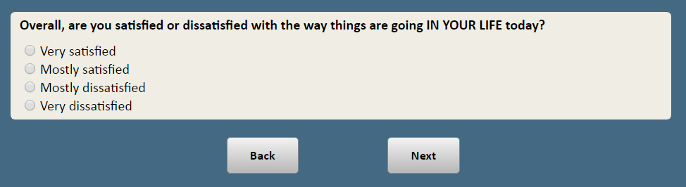

**RANDOMIZE ORDER OF “MOSTLY POSITIVE” AND “MOSTLY NEGATIVE” IN QUESTION STEM WITH RESPONSE OPTIONS IN SAME ORDER**

**ASK ALL:**

INSTVIEW Do you have a **[RANDOMIZE ORDER: “**mostly positive or mostly negative,” “mostly negative or mostly positive”**]** view of the following groups and institutions? **[RANDOMIZE ITEMS]**

1. The federal government
2. Large corporations
3. The national news media
4. Churches and religious organizations
5. Colleges and universities
6. The military

**RESPONSE OPTIONS [RANDOMIZE 1 AND 2 IN SAME ORDER AS STEM, 3 ALWAYS LAST:]**

1    Mostly positive view

2    Mostly negative view

3    Neither positive nor negative view

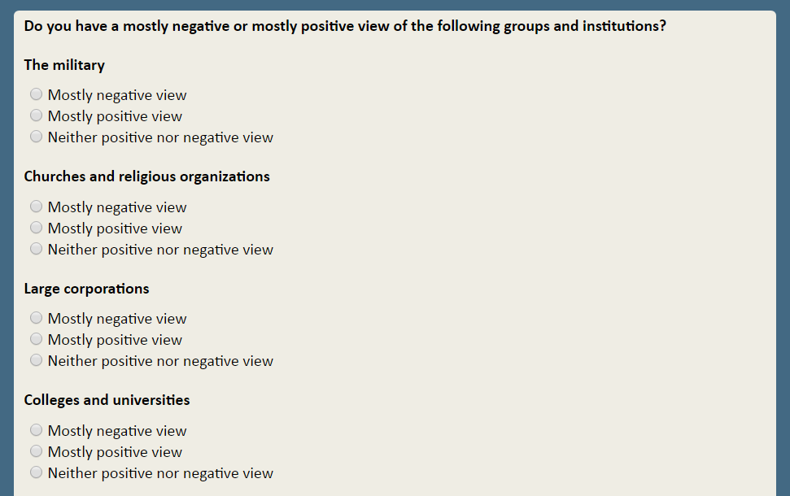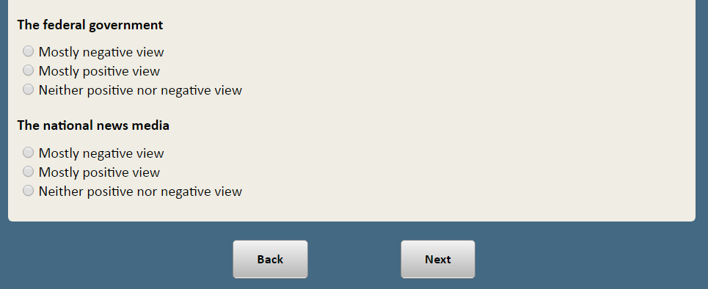

**ASK ALL:**

GOVT_ROLEWhich statement comes closer to your own views — even if neither is exactly

right?

**[PROGRAMMING NOTE: RANDOMIZE RESPONSE OPTIONS]**

1. Government should do more to solve problems
2. Government is doing too many things better left to businesses and individuals

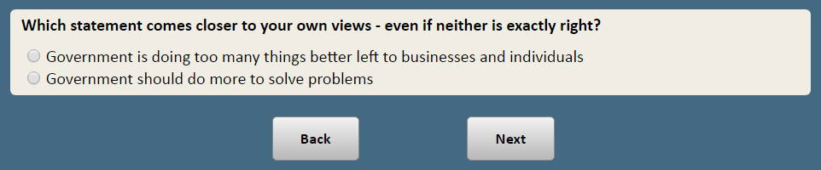

**ASK ALL:**

IMMCULT2 Which statement comes closer to your own views — even if neither is exactly right? **[PROGRAMMING NOTE: RANDOMIZE RESPONSE OPTIONS]**

1 The growing number of newcomers from other countries threatens traditional American customs and values

2 The growing number of newcomers from other countries strengthens American society

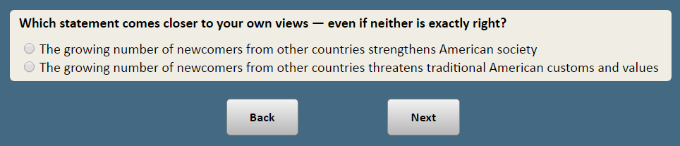

**ASK ALL:**

MORALISSUE Do you personally believe thateach of the following is **[RANDOMIZE ORDER: “**morally acceptable,” “morally wrong,”**]** or is it not a moral issue?

**[RANDOMIZE LIST]**

**NO ITEM a**

b. Having an abortion

c. Homosexual behavior

d. Drinking alcohol

**RESPONSE OPTIONS [RANDOMIZE 1 AND 2 IN SAME ORDER AS STEM, 3 ALWAYS LAST]**

1 Morally acceptable

2 Morally wrong

3 Not a moral issue

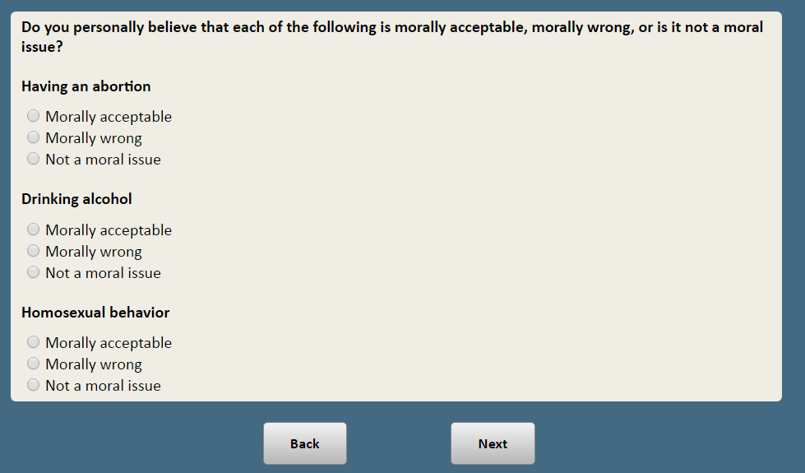

**ASK ALL:**

EQUALITY Which of these two statements comes closer to your own views – even if neither is exactly right? **[DO NOT ROTATE RESPONSES]**

1 Our country has made the changes needed to give blacks equal rights with whites

2 Our country needs to continue making changes to give blacks equal rights with whites

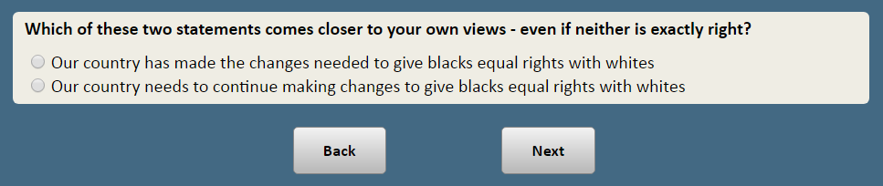

**ASK ALL:**

ENV20A Which of these three statements about the Earth’s temperature comes closest to your view? **[RANDOMIZE RESPONSE OPTIONS 1 and 2; KEEP 3 and 8 LAST]:**

1 The Earth is getting warmer mostly because of natural patterns in the Earth’s environment

2 The Earth is getting warmer mostly because of human activity, such as burning fossil fuels

3 There is no solid evidence the Earth is getting warmer

8 Not sure

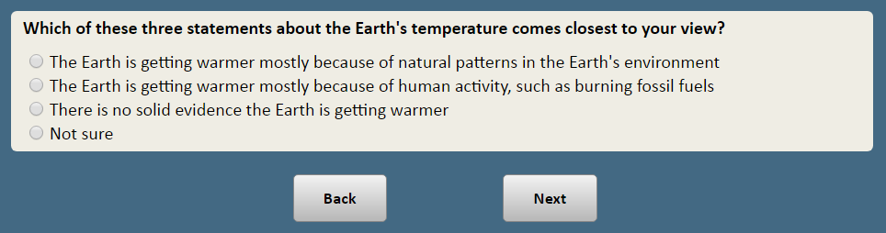

**ASK ALL:**

GODMORAL Which of these statements comes closer to your view, even if neither is exactly right?

**[RANDOMIZE RESPONSE OPTIONS]**

1. It is not necessary to believe in God in order to be moral and have good values

2 It is necessary to believe in God in order to be moral and have good values

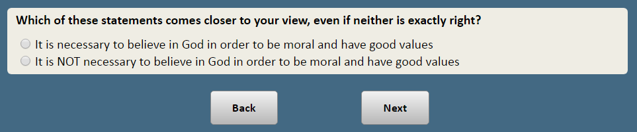

**ASK ALL:**

SHAREVAL How important, if at all, is it to you to belong to a community of people who share your values and beliefs?

1 Very important

2 Somewhat important

3 Not too important

4 Not at all important

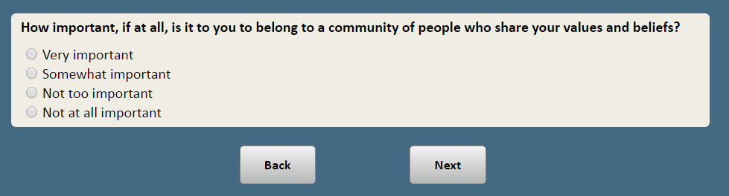

**ASK ALL:**

GUIDE_1 How much, if at all, do you look to each of the following to help you make decisions about what is right and wrong?

**[RANDOMIZE ITEMS]**

1. Religious teachings and beliefs
2. Philosophy and reason
3. Practical experience and common sense
4. Scientific information

**RESPONSE CATEGORIES:**

1 A lot

2 Some

3 Not much

4 Not at all

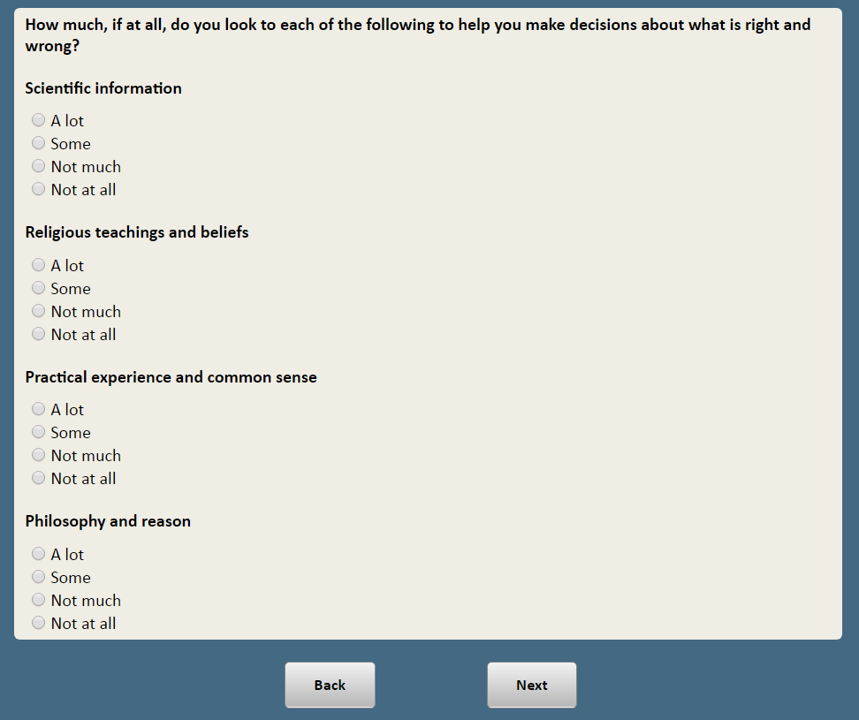

**ASK IF SELECTED MORE THAN ONE ITEM AS “A LOT” IN GUIDE_1:**

GUIDE_2Which of these do you rely on the MOST to help you make decisions about what is right and wrong?

**[PROGRAMMING NOTE: DISPLAY SELECTED RESPONSE OPTIONS IF SELECTED MORE THAN ONE ITEM AS “A LOT” IN GUIDE_1]**

1. Religious teachings and beliefs
2. Philosophy and reason
3. Practical experience and common sense
4. Scientific information

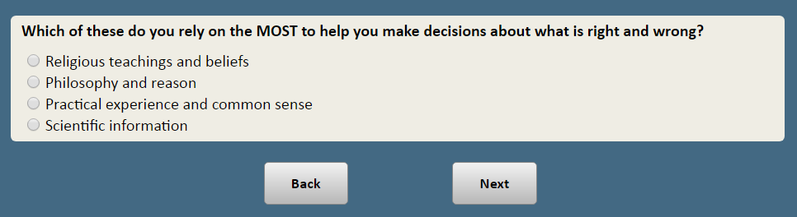

**ASK ALL:**

MEANING_1 Many things can make a person feel that their life is meaningful and fulfilling. Regardless of how much time you spend doing it, how much meaning and fulfillment, if any, does each of the following provide you?

**[RANDOMIZE ITEMS a-h]**

1. Your religious faith
2. Spiritual practices, such as meditation
3. Volunteer work
4. Being outdoors and experiencing nature
5. Arts or crafts, such as painting, making music or pottery
6. Spending time with family
7. Reading
8. Watching television shows or videos

**RESPONSE CATEGORIES:**

1 A great deal

2 Some

3 Not much

4 None at all

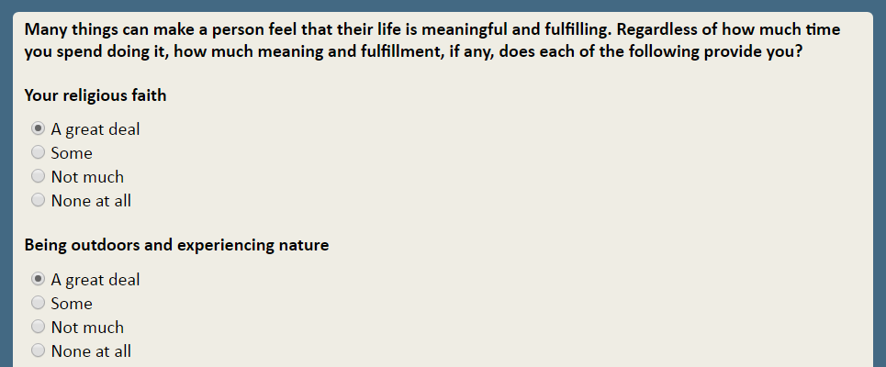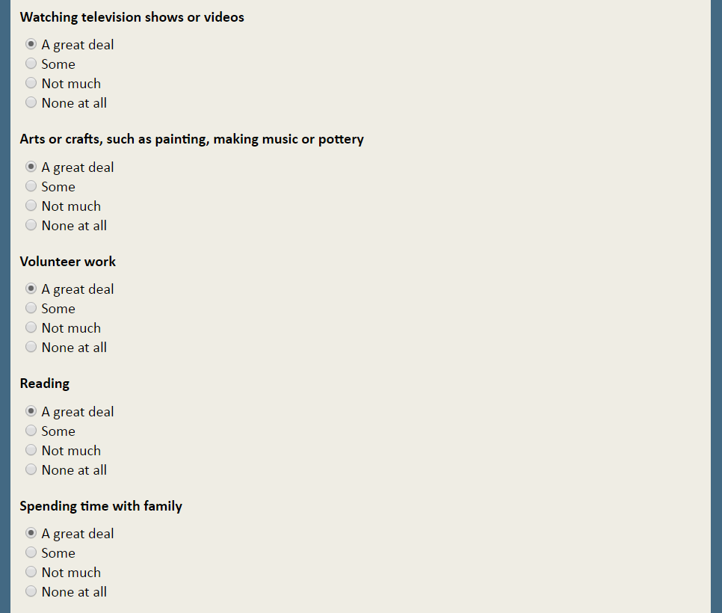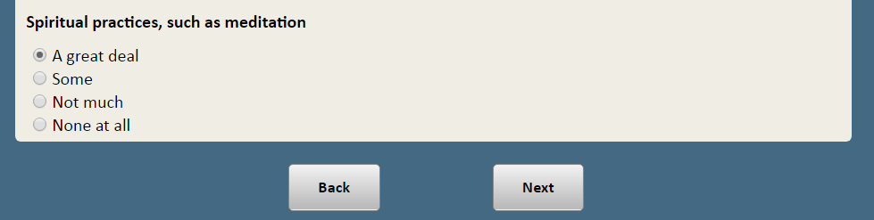

**ASK ALL:**

MEANING_2 Now still thinking about what gives your life meaning and fulfillment, regardless of how much time you spend doing it, how much meaning and fulfillment, if any, does each of the following provide you?

**[RANDOMIZE ITEMS]**

1. Spending time with friends
2. Your job or career
3. Caring for pets or animals
4. Participating in sports or exercising
5. Supporting a social or political cause
6. Listening to music

**RESPONSE CATEGORIES:**

1 A great deal

2 Some

3 Not much

4 None at all

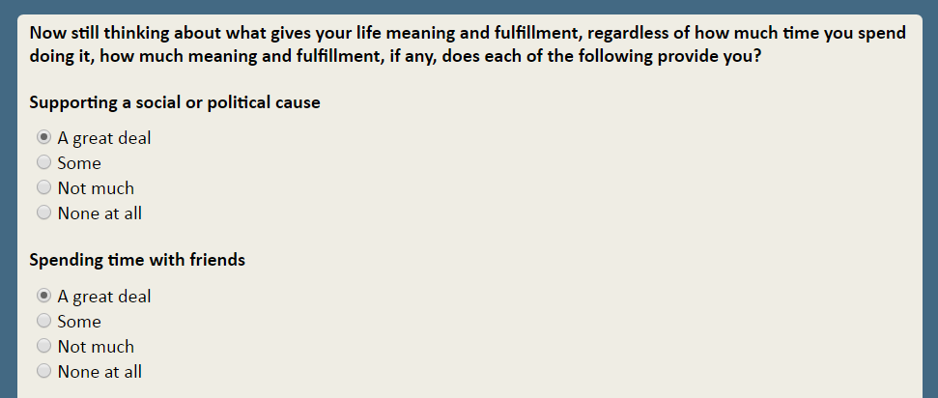

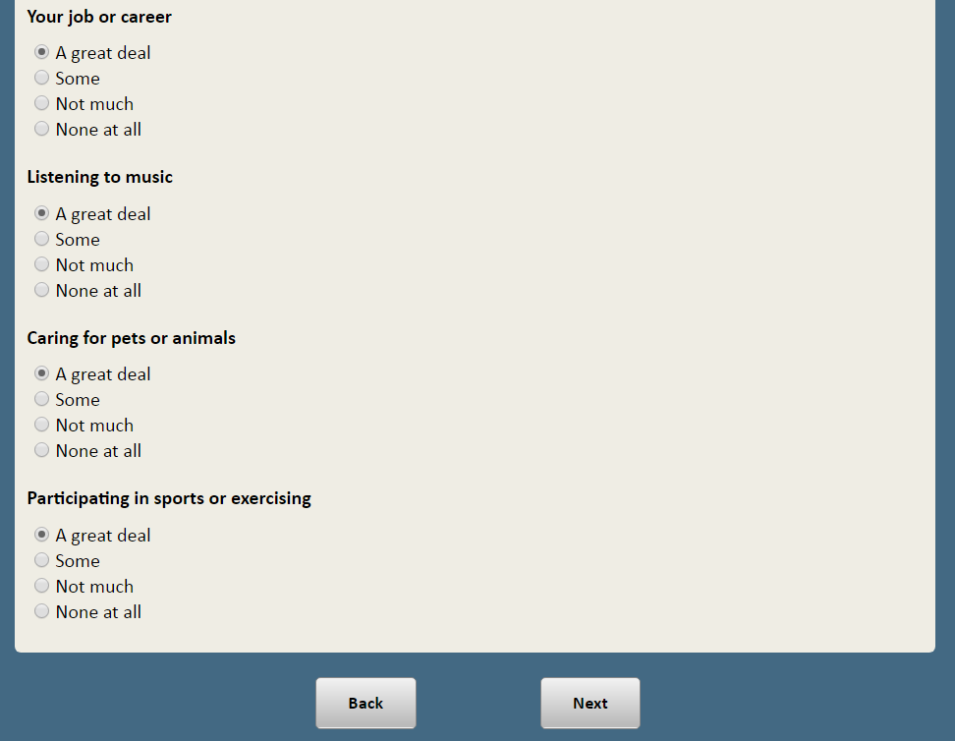

**ASK ALL:**

MEANING_2o Is there something else not listed previously that gives your life a GREAT DEAL of meaning and fulfillment?

1 Yes

2 No

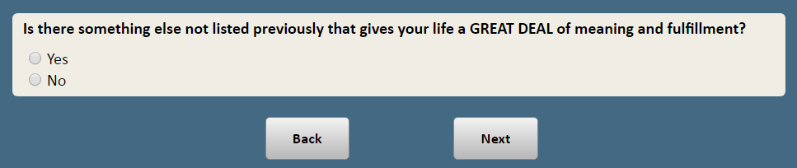

**ASK IF SELECTED MORE THAN ONE ITEM AS “A GREAT DEAL” IN MEANING_1, MEANING_2 OR MEANING_2o:**

MEANING_3 What is the MOST IMPORTANT source of meaning and fulfillment in your life?

**[PROGRAMMING NOTE: DISPLAY SELECTED RESPONSE OPTIONS IF SELECTED MORE THAN ONE ITEM AS “A GREAT DEAL” IN MEANING_1, MEANING_2 OR MEANING_2o.]**

1. Your religious faith
2. Spiritual practices, such as meditation
3. Volunteer work
4. Being outdoors and experiencing nature
5. Arts or crafts, such as painting, making music or pottery
6. Spending time with family
7. Reading
8. Watching television shows or videos
9. Spending time with friends
10. Your job or career
11. Caring for pets or animals
12. Participating in sports or exercising
13. Supporting a social or political cause
14. Listening to music
15. Something else

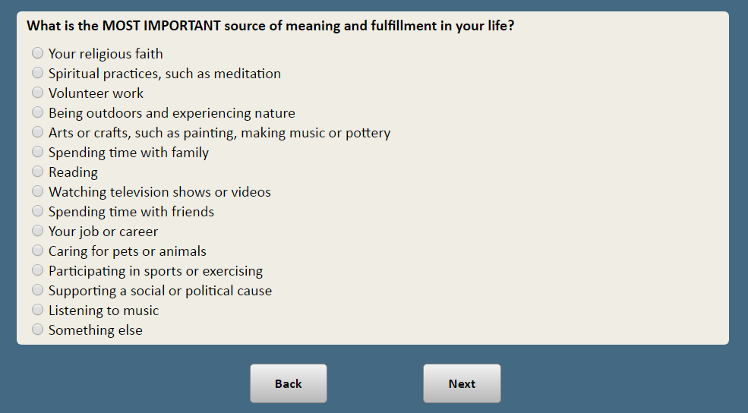

**ASK ALL:**

RELIMP How important is religion in your life?

1 Very important

2 Somewhat important

3 Not too important

4 Not at all important

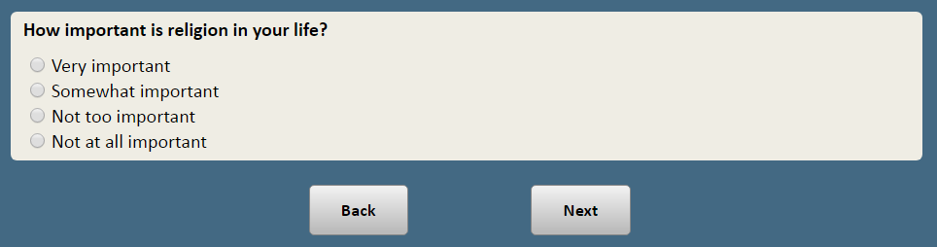

**ASK IF RESPONDENT SAID RELIGION VERY IMPORTANT (RELIMP=1):**

RELMOST Which statement comes closer to your views, even if neither is exactly right?

**[RANDOMIZE RESPONSE OPTIONS]**

1 My religion is the single most important thing in my life

2 Although my religious beliefs are important, there are other things in my life that are equally important or more important

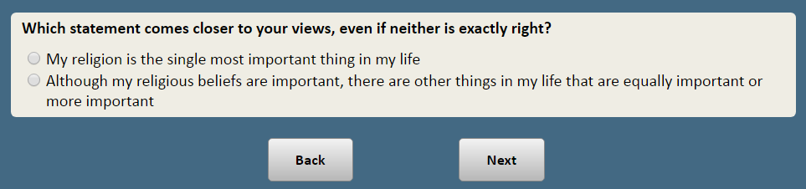

Now, thinking about churches and religious organizations here in the United States…

**ASK ALL:**

CHURCHMORAL Do you think churches and religious organizations…

**[RANDOMIZE RESPONSE OPTIONS 1 & 2, 3 ALWAYS LAST]**

1 Strengthen morality in society

2 Weaken morality in society

3 Don’t make much difference

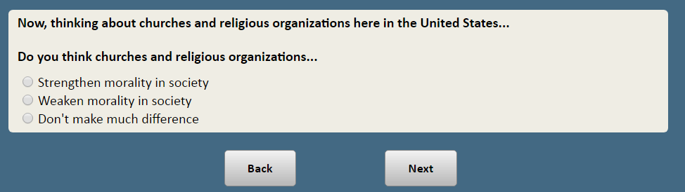

**ASK ALL:**

CHURCHPOL Do you think churches and religious organizations have…

**[RANDOMIZE RESPONSE OPTIONS 1 & 2, 3 ALWAYS LAST]**

1 Too much influence in politics

2 Not enough influence in politics

3 About the right amount of influence in politics

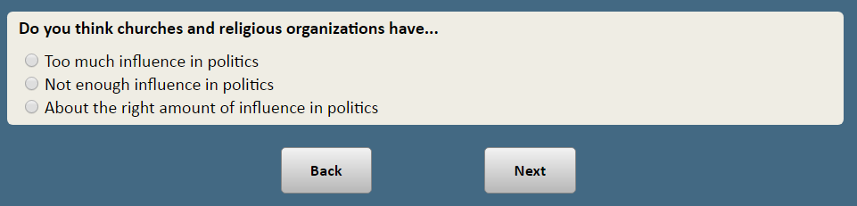

**ASK ALL:**

CHURCHUNITE Do you think churches and religious organizations…

**[RANDOMIZE RESPONSE OPTIONS 1 & 2, 3 ALWAYS LAST]**

1 Mostly bring people together

2 Mostly push people apart

3 Neither

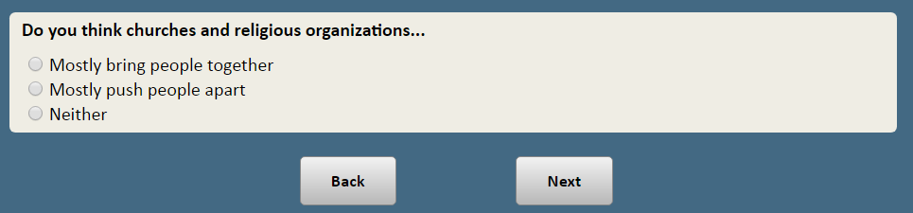

**ASK ALL:**

CHURCHIMPACT Considering everything, what impact do churches and religious organizations have on American society?

**[RANDOMIZE RESPONSE OPTIONS 1 & 2, 3 ALWAYS LAST]**

1 They do more harm than good

2 They do more good than harm

3 Don’t make much difference

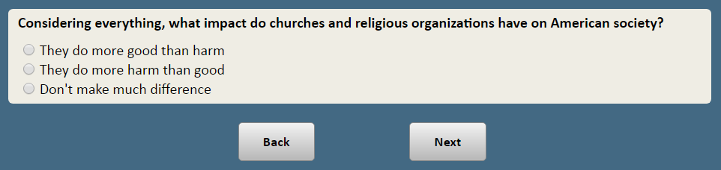

Thinking now about your attendance at religious services…

**ASK RESPONDENTS WHO ATTEND RELIGIOUS SERVICES ONCE OR TWICE A MONTH OR MORE OFTEN:**

REASONATTEND_1 People attend religious services for many reasons. How important, if at all, is each of the following reasons for why you personally attend religious services?

**[PROGRAMMING NOTE: RANDOMIZE a-e]**

a. To become closer to God

b. To be part of a community of faith

c. To continue my family’s religious traditions

d. To meet new people or to socialize

e. Because I feel a religious obligation to go

**RESPONSE CATEGORIES:**

Top of Form1 Very important

2 Somewhat important

3 Not important

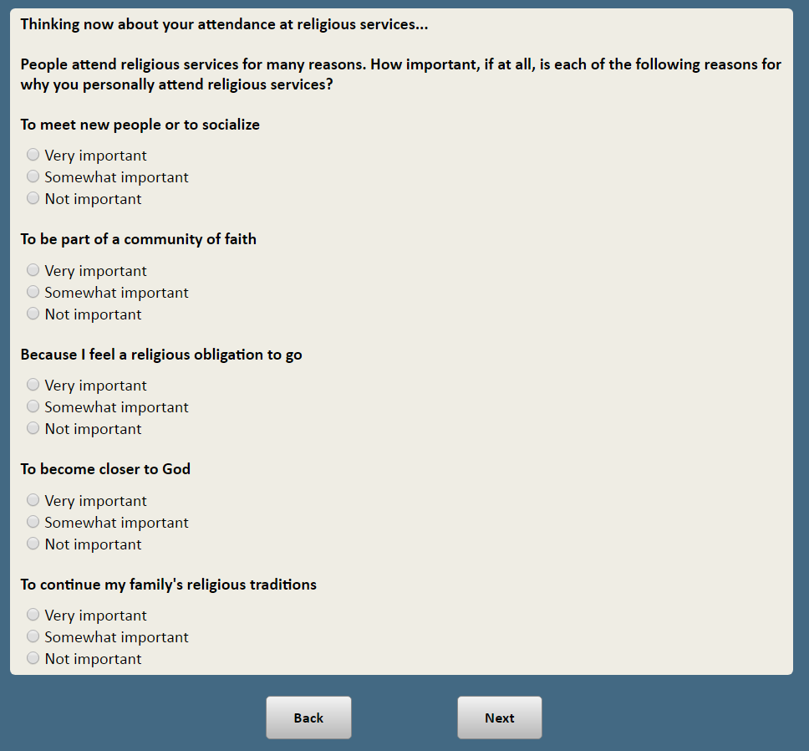

**ASK RESPONDENTS WHO ATTEND RELIGIOUS SERVICES ONCE OR TWICE A MONTH OR MORE OFTEN:**

REASONATTEND_2 And now, still thinking about why you attend religious services, how important, if at all, is each of the following reasons for why you personally attend religious services? **[RANDOMIZE]**

f. For comfort in times of trouble and sorrow

g. To make me a better person

h. I find the sermons valuable

i. To please my family, spouse or partner

j. So my children will grow up with a moral foundation

**RESPONSE CATEGORIES:**

Top of Form1 Very important

2 Somewhat important

3 Not important

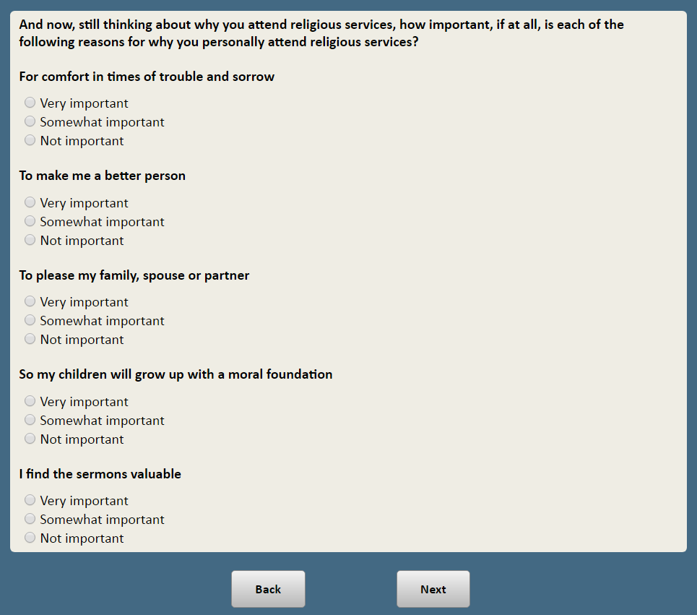

**ASK IF RESPONDENT SELECTED MORE THAN ONE ITEM AS “VERY IMPORTANT” IN REASONATTEND_1 OR REASONATTEND_2:**

REASONATTEND_3 What is the most important reason you attend religious services?

**[PROGRAMMING NOTE: DISPLAY SELECTED ITEMS IF SELECTED MORE THAN ONE ITEM AS “VERY IMPORTANT” IN REASONATTEND_1 OR REASONATTEND_2]**

1. To become closer to God
2. To be part of a community of faith
3. To continue my family’s religious traditions
4. To meet new people or to socialize
5. Because I feel a religious obligation to go
6. For comfort in times of trouble and sorrow
7. To make me a better person
8. I find the sermons valuable
9. To please my family, spouse or partner
10. So my children will grow up with a moral foundation

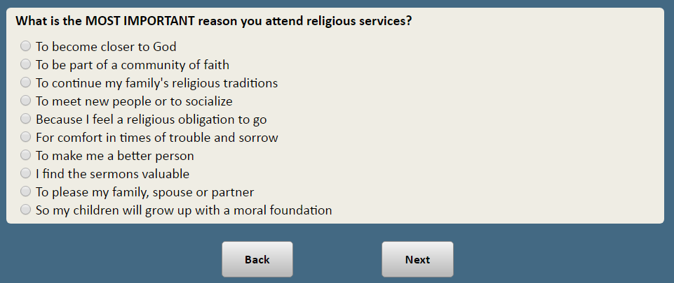

**ASK IF ATTEND RELIGIOUS SERVICES A FEW TIMES A YEAR OR LESS OFTEN:**

NOATTEND In a previous survey you indicated that you **[IF ATTENDS A FEW TIMES A YEAR:** “only attend religious services a few times a year”, **IF SELDOM ATTENDS:** “seldom attend religious services”, **IF NEVER ATTENDS:** “never attend religious services”**]**. How important, if at all, is each of the following reasons for why you **[IF ATTENDS A FEW TIMES A YEAR:** “only attend religious services a few times a year”, **IF SELDOM ATTENDS:** “seldom attend religious services”, **IF NEVER ATTENDS:** “never attend religious services”**]**?

**[RANDOMIZE]**

a. I am not a believer

b. I don’t have the time

c. I haven’t found a church or other house of worship I like

d. There isn’t a church or other house of worship for my religion in my area

e. I don’t like the sermons

f. I don’t feel welcome

g. I’m in poor health or find it difficult to get around

h. I practice my faith in other ways

**RESPONSE CATEGORIES:**

Top of Form1 Very important

2 Somewhat important

3 Not important

1. Bottom of Form

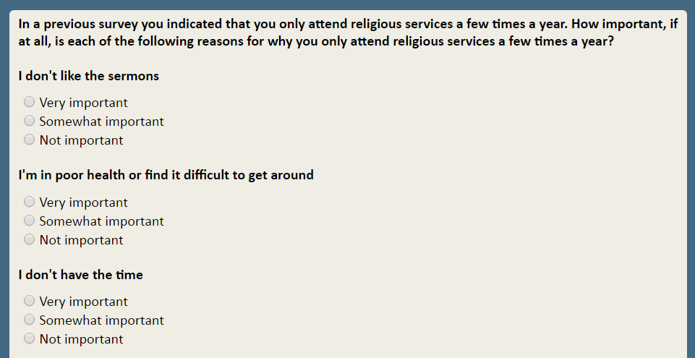

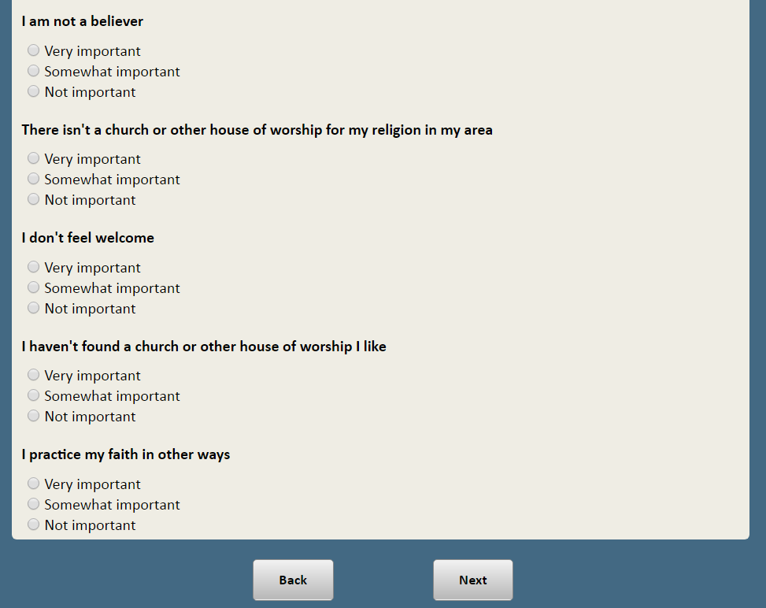

**ASK IF ATTEND A FEW TIMES A YEAR OR SELDOM:**

ATTENDHOL Aside from weddings and funerals, when you attend religious services, is it…

1 Almost always on religious holidays [**IF CHRISTIAN:**, such as Christmas or Easter]

2 Almost always at other times

3 Sometimes for religious holidays and sometimes for other occasions

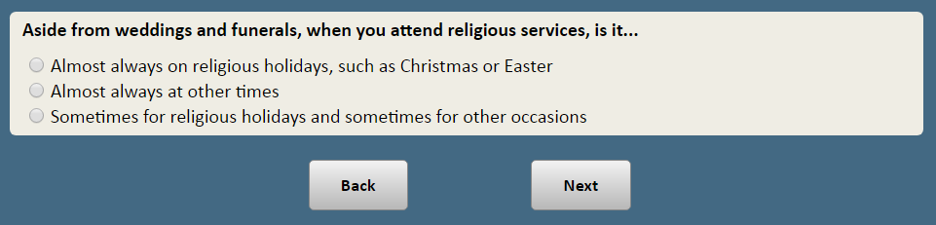

**ASK RESPONDENTS WHO ATTEND RELIGIOUS SERVICES ONCE OR TWICE A MONTH OR MORE OFTEN:**

ATTENDEXP How often do you experience each of the following when you attend religious services? **[RANDOMIZE]**

1. A sense of God’s presence
2. A sense of connection to a longstanding tradition
3. A sense of community with people who share your religion

**RESPONSE CATEGORIES:**

1 Always

2 Often but not always

3 Sometimes

4 Rarely

5 Never

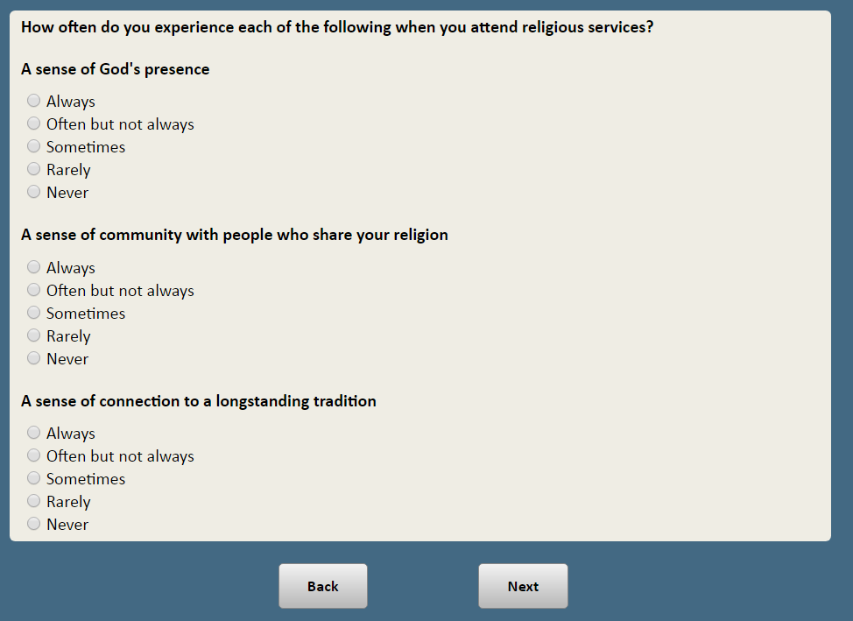

**ASK RESPONDENTS WHO ATTEND RELIGIOUS SERVICES ONCE OR TWICE A MONTH OR MORE OFTEN:**

CHURCHACT Besides attending religious services, how often do you take part in other activities connected with your church or house of worship, for example, volunteering, participating in prayer groups, or sharing community meals?

1 At least once a week

2 Once or twice a month

3 Several times a year

4 Seldom

5 Never

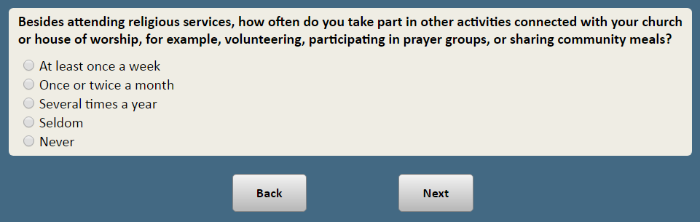

**ASK ALL:**

PRAY Other than during religious services, how often do you pray?

1 Several times a day

2 Once a day

3 A few times a week

4 Once a week

5 A few times a month

6 Seldom

7 Never

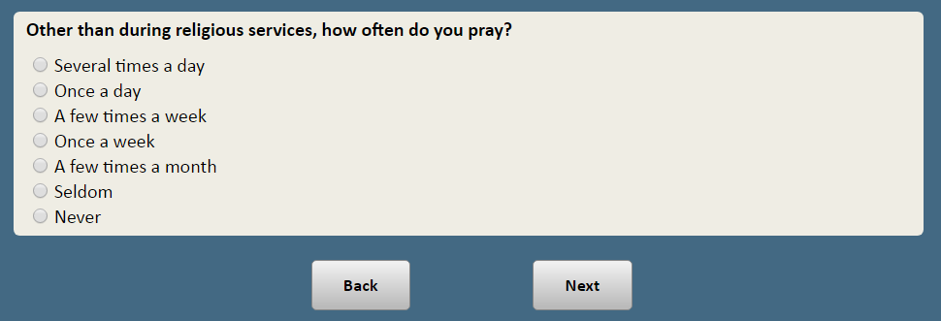

**ASK ALL:**

READBIB How often, if at all, do you read **[Holy book: If Christian or no religion insert** “the Bible”**; If Jewish, insert** “the Torah”; **If Muslim, insert,** “the Quran”**; If other non-Christian affiliations, insert** “holy scripture”**; IF DK/REF IN RELIGION, insert** "the Bible"**]** outside of religious services?

1 Several times a day

2 Once a day

3 A few times a week

4 Once a week

5 A few times a month

6 Seldom

7 Never

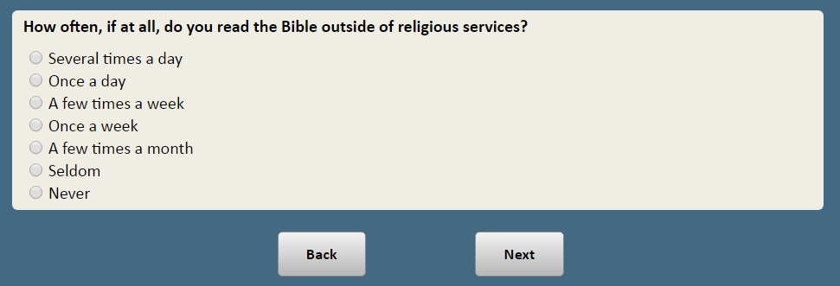

**ASK ALL:**

LITERAL Which comes closest to your views, even if none is exactly right?

**[Holy book: If Christian or no religion insert** “The Bible”**; If Jewish, insert** “The Torah”; **If Muslim, insert,** “The Quran”**; If other non-Christian affiliations, insert** “The holy scripture”**; IF DK/REF IN RELIGION, insert** "The Bible"**]**

1 **[Holy book]** is the word of God and should be taken literally, word for word

2 **[Holy book]** is the word of God, but not everything in it should be taken literally, word for word

3 **[Holy book]** is a book written by people and is not the word of God

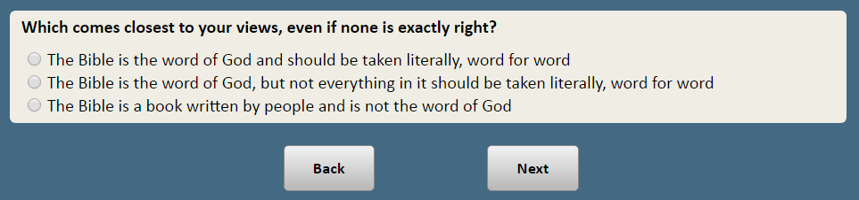

**ASK ALL:**

RELMEDIA How often, if at all, do you watch or listen to religious programs on TV, the radio or online?

1 At least once a week

2 Once or twice a month

3 Several times a year

4 Seldom

5 Never

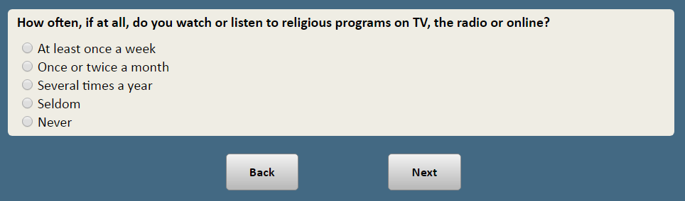

**ASK ALL AFFILIATED:**

RELHELP_1 How much, if at all, do you find that your religious beliefs help you in…

* 1. Your family relationships
  2. Your relationships with other people, such as friends and neighbors

**RESPONSE CATEGORIES:**

1 A lot

2 Some

3 Not much

4 Not at all

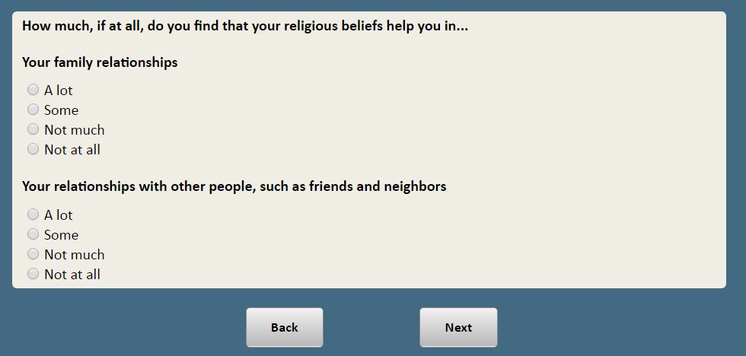

**ASK ALL AFFILIATED:**

RELHELP_2 How much, if at all, do you find that your religious beliefs help you in…

**[RANDOMIZE OPTIONS]**

* 1. The way you do your job or pursue your career
  2. Coping with difficult times in life
  3. Doing what’s right, even when it’s hard

**RESPONSE CATEGORIES:**

1 A lot

2 Some

3 Not much

4 Not at all

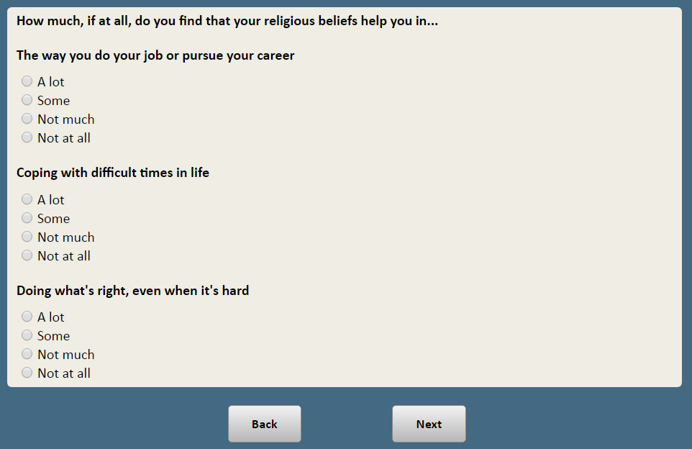

**ASK ALL:**

ACTVORG_1 Are you currently active in any of the following groups or organizations, or not? **[RANDOMIZE]**?

1. Church groups or other religious or spiritual organizations
2. A book club or study group
3. A performing arts, singing or dance group
4. A professional association, trade association or union
5. A parent group or youth organization, such as PTA, scouts or youth sports

**RESPONSE CATEGORIES:**

1 Yes, active

2 No, not active

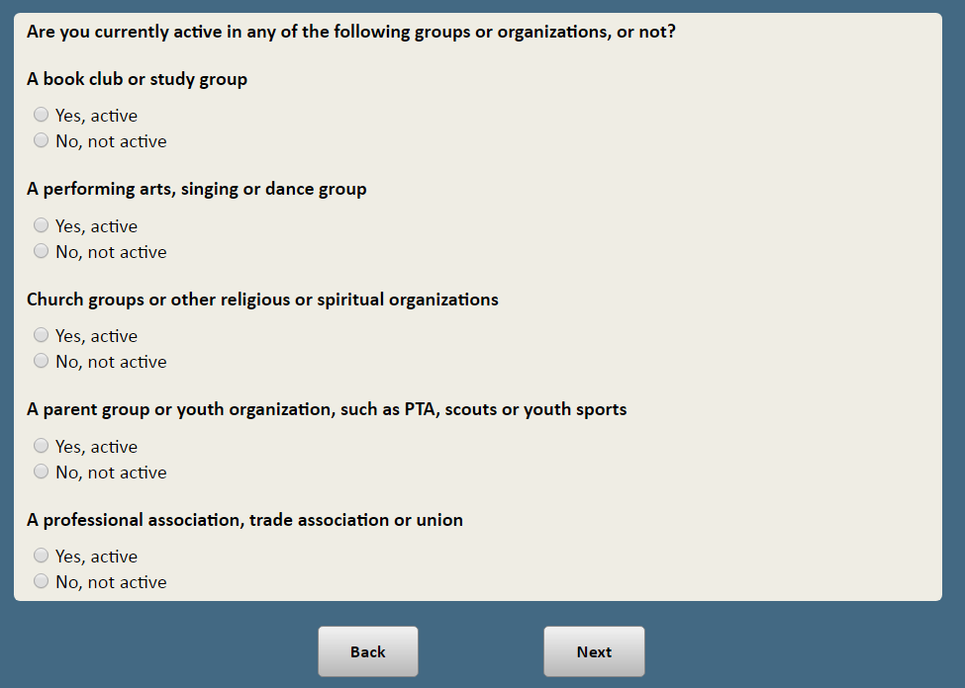

**ASK ALL:**

ACTVORG_2 Are you currently active in any of the following groups or organizations, or not? **[RANDOMIZE f-j]**?

1. A social club, sorority or fraternity
2. A veterans group such as American Legion or VFW
3. A hobby group or club
4. A charitable or volunteer organization
5. A community group or neighborhood association

**RESPONSE CATEGORIES:**

1 Yes, active

2 No, not active

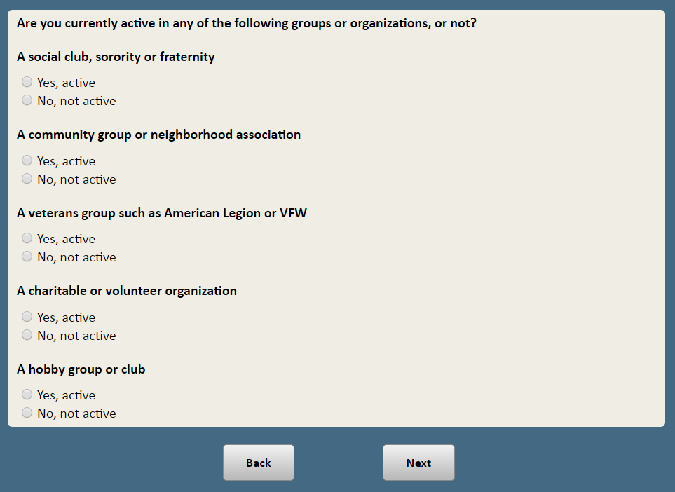

**ASK ALL:**

ACTVORG_2k Are you currently active in any other group or organization not already listed?

1 Yes, active

2 No, not active

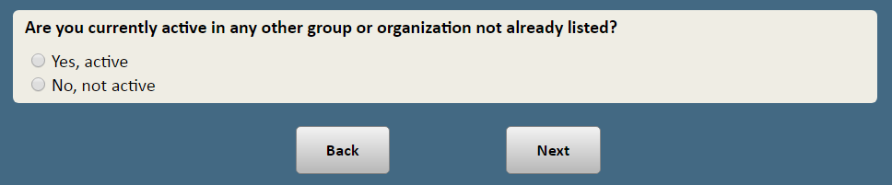

**RANDOMIZE ORDER OF RELPER AND SPIRPER**

**ASK ALL:**

RELPER To what extent do you consider yourself a religious person? Are you…

1 Very religious

2 Somewhat religious

3  Not too religious

4  Not at all religious

**ASK ALL:**

SPIRPER To what extent do you consider yourself a spiritual person? Are you…

1 Very spiritual

2 Somewhat spiritual

3  Not too spiritual

4 Not at all spiritual

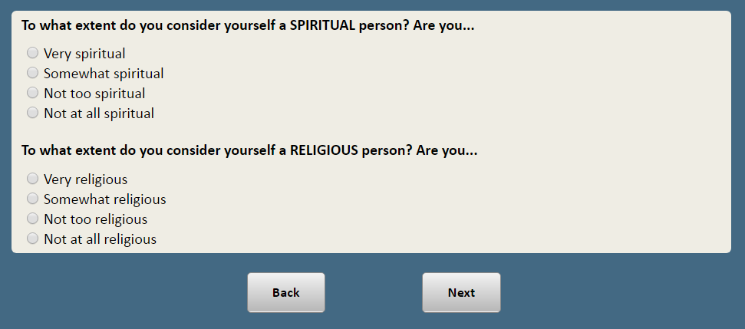

**ASK ALL:**

GOD Do you believe in God, or not?

1 Yes

2 No

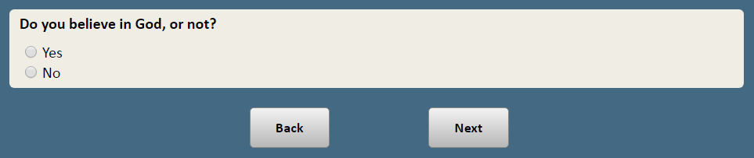

**ASK IF BELIEVES IN GOD (GOD=1):**

GODBIBLE Which of these statements comes closer to your views, even if neither is exactly right?

**[RANDOMIZE]**

1 I believe in God as described in the Bible

2 I DO NOT believe in God as described in the Bible, but I do believe there is some other higher power or spiritual force in the universe

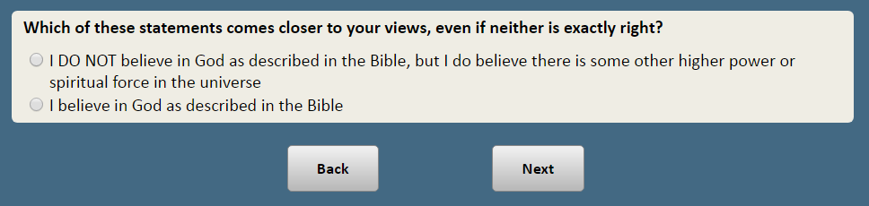

**ASK IF DOES NOT BELIEVE IN GOD (GOD=2):**

HGHPWR Which of these statements comes closer to your views, even if neither is exactly right?

**[RANDOMIZE]**

1 I DO NOT believe in God as described in the Bible, but I do believe there is some other higher power or spiritual force in the universe

2 I do not believe there is ANY higher power or spiritual force in the universe

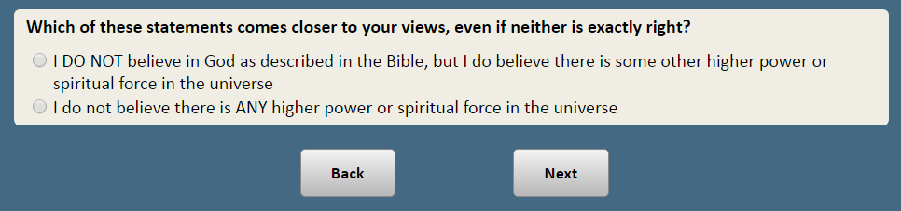

**ASK IF REFUSED GOD (GOD=99):**

MISSINGGOD Which of these statements comes closest to your views, even if none is exactly right?

1 I believe in God as described in the Bible

2 I DO NOT believe in God as described in the Bible, but I do believe there is some other higher power or spiritual force in the universe

3 I do not believe there is ANY higher power or spiritual force in the universe

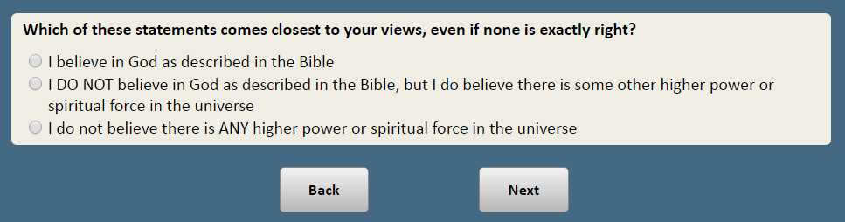

**ASK IF BELIEVES IN GOD OR HIGHER POWER:**

GODBELIEFS Which of the following, if any, do you believe about **[IF BELIEVES IN GOD OF BIBLE INSERT:** God**;** **IF DOESN’T BELIEVE IN GOD OF BIBLE BUT BELIEVES IN SOMETHING ELSE INSERT:** the higher power or spiritual force in the universe**]**?

Do you believe that **[IF BELIEVES IN GOD OF BIBLE INSERT:** God**;** **IF DOESN’T BELIEVE IN GOD OF BIBLE BUT BELIEVES IN SOMETHING ELSE INSERT:** the higher power or spiritual force in the universe**]**…

**[RANDOMIZE ITEMS]**

a. Knows everything that goes on in the world

b. Has the power to direct or change everything that goes on in the world

c. Loves all people regardless of their faults

d. Will judge all people on what they have done

**RESPONSE CATEGORIES:**

1 Yes

2 No

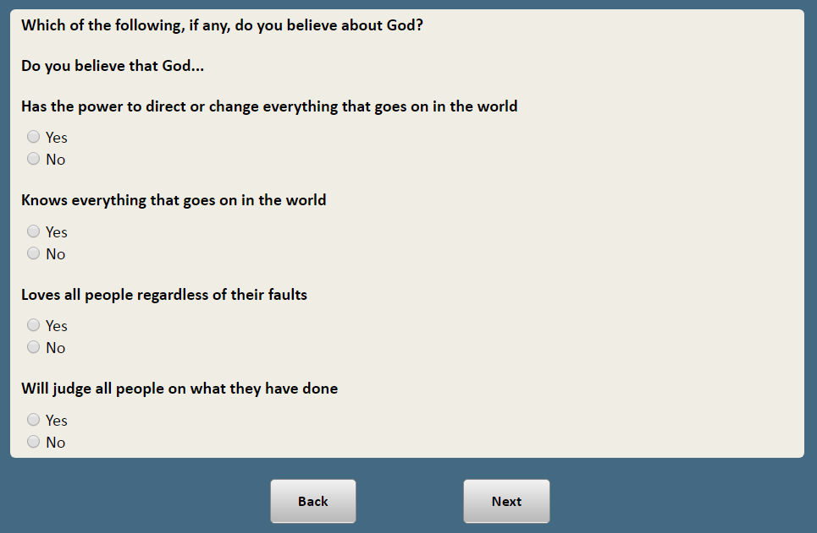

**ASK IF BELIEVES IN GOD OR HIGHER POWER:**

TALKGOD Do you ever try to talk to **[IF BELIEVES IN GOD OF BIBLE INSERT:** God**;** **IF DOESN’T BELIEVE IN GOD OF BIBLE BUT BELIEVES IN SOMETHING ELSE INSERT:** the higher power or spiritual force in the universe**]**, or not?

1 Yes

2 No

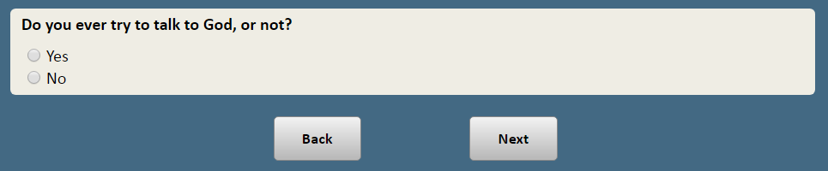

**ASK IF BELIEVES IN GOD OR HIGHER POWER:**

GODRESPOND Does **[IF BELIEVES IN GOD OF BIBLE INSERT:** God**;** **IF DOESN’T BELIEVE IN GOD OF BIBLE BUT BELIEVES IN SOMETHING ELSE INSERT:** the higher power or spiritual force in the universe**]** evertalk directly with you, or not?

1 Yes

2 No

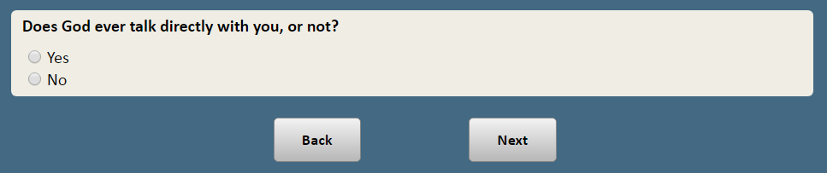

**ASK IF BELIEVES IN GOD OR HIGHER POWER:**

GODACT Do you think **[IF BELIEVES IN GOD OF BIBLE INSERT:** God**;** **IF DOESN’T BELIEVE IN GOD OF BIBLE BUT BELIEVES IN SOMETHING ELSE INSERT:** the higher power or spiritual force in the universe**]** has ever…

**[RANDOMIZE ITEMS]**

a. Rewarded you

b. Punished you

c. Protected you

**RESPONSE CATEGORIES:**

1 Yes

2 No

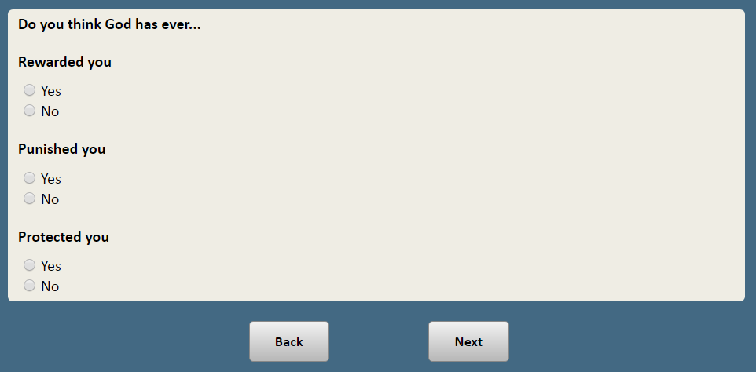

**ASK IF BELIEVES IN GOD OR HIGHER POWER:**

GODDTRMN Do you think **[IF BELIEVES IN GOD OF BIBLE INSERT:** God**;** **IF DOESN’T BELIEVE IN GOD OF BIBLE BUT BELIEVES IN SOMETHING ELSE INSERT:** the higher power or spiritual force in the universe**]** directly determines what happens in your life…

1 All of the time

2 Most of the time

3 Just some of the time

4 Hardly ever

5 Never

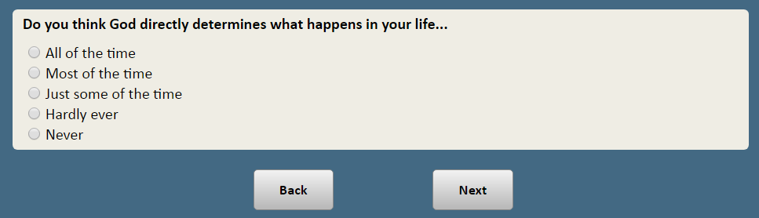

**ASK IF GOD OR HIGHER POWER DETERMINES WHAT HAPPENS IN LIFE MOST OF THE TIME, SOME OF THE TIME OR HARDLY EVER (GODDTRMN=2, 3, 4):**

DTRMNALL Which things do you think **[IF BELIEVES IN GOD OF BIBLE:** God**;** **IF DOESN’T BELIEVE IN GOD OF BIBLE BUT BELIEVES IN SOMETHING ELSE INSERT:** the higher power or spiritual force in the universe**]** directly determines in your life?

1 Just the little things

2 Just the big things

3 A mix of big and little things

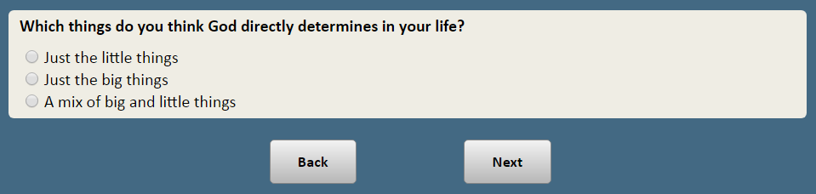

**ASK IF GOD OR HIGHER POWER DETERMINES WHAT HAPPENS IN LIFE MOST OF THE TIME, SOME OF THE TIME OR HARDLY EVER (GODDTRMN=2, 3, 4):**

DTRMNGOOD Do you think **[IF BELIEVES IN GOD OF BIBLE:** God**;** **IF DOESN’T BELIEVE IN GOD OF BIBLE BUT BELIEVES IN SOMETHING ELSE INSERT:** the higher power or spiritual force in the universe**]** determines…

1 Only the good things that happen to you

2 Only the bad things that happen to you

3 A mix of good and bad things that happen to you

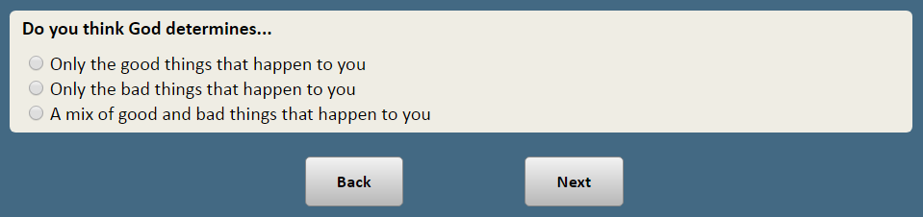

**ASK ALL:**

BELIEVE Which of the following, if any, do you believe in? **[RANDOMIZE ITEMS]**

a. Heaven

b. Hell

c. Spiritual energy located in physical things, such as mountains, trees or crystals

d. Reincarnation (people will be reborn again and again in this world)

e. Astrology (the position of stars and planets can affect people’s lives)

f. Psychics (that some people perceive or are sensitive to supernatural forces)

**RESPONSE CATEGORIES:**

1 Yes, believe in

2 No, don’t believe

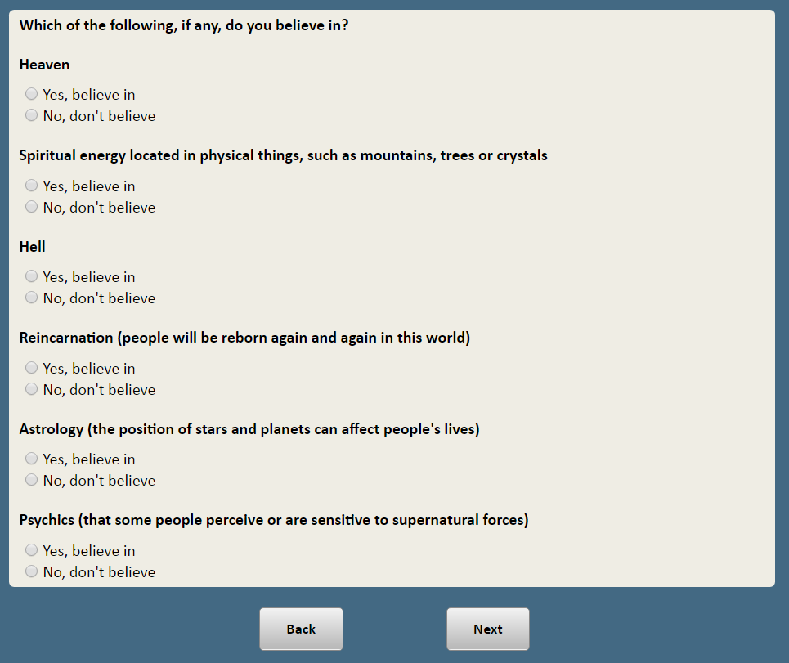

**ASK IF UNAFFILIATED:**

WHYNONE_1 In a previous survey, you told us that, when it comes to religion, you are **[IF ATHEIST,** “an atheist”; **IF AGNOSTIC,** “agnostic”, **IF** **NOTHING IN PARTICULAR,** “nothing in particular”**]**.How important, if at all, is each of the following reasons for why **[IF ATHEIST,** “you are an atheist”; **IF AGNOSTIC,** “you are agnostic”, **IF NOTHING IN PARTICULAR,** “your religion is nothing in particular”**]**?

**[RANDOMIZE]**

1. I don’t believe in God
2. I don’t like religious leaders
3. I don’t like religious organizations
4. I question a lot of religious teachings
5. Religion is irrelevant to me
6. I don’t like the positions that churches take on social or political issues

**RESPONSE CATEGORIES:**

1 Very important

2 Somewhat important

3 Not important at all

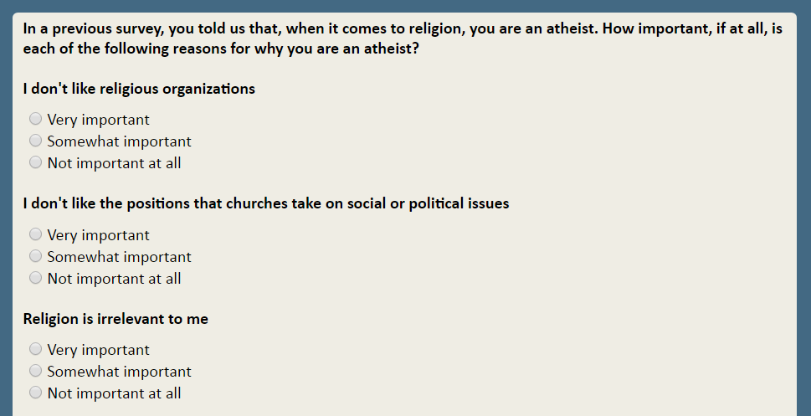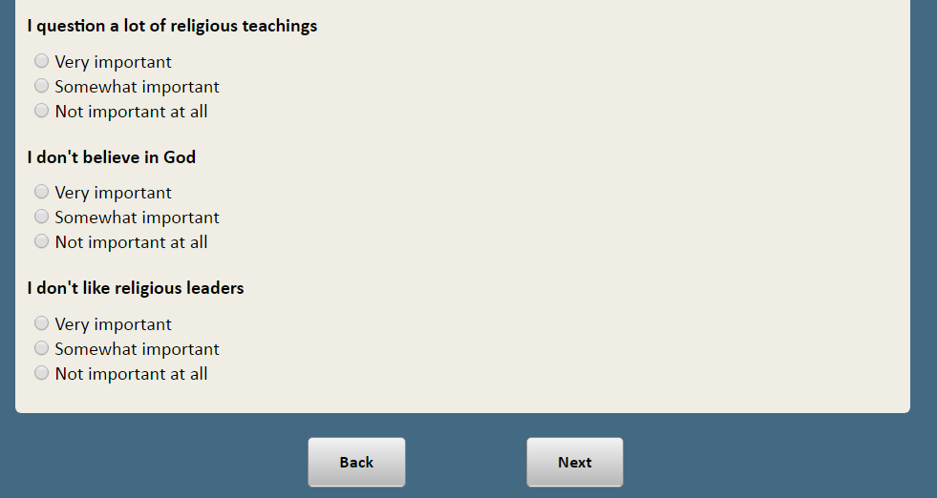

**ASK IF UNAFFILIATED AND IF SELECTED MORE THAN ONE ITEM AS “VERY IMPORTANT” IN WHYNONE_1:**

WHYNONE_2 What is the MOST important reason that you are **[IF ATHEIST,** “an atheist”; **IF AGNOSTIC,** “agnostic”, **IF NOTHING IN PARTICULAR,** “nothing in particular”**]**?

**[PROGRAMMING NOTE: DISPLAY SELECTED ITEMS IF SELECTED MORE THAN ONE ITEM AS “VERY IMPORTANT”]**

1 I don’t believe in God

2 I don’t like religious leaders

3 I don’t like religious organizations

4 I question a lot of religious teachings

5 Religion is irrelevant to me

6 I don’t like the positions that churches take on social or political issues

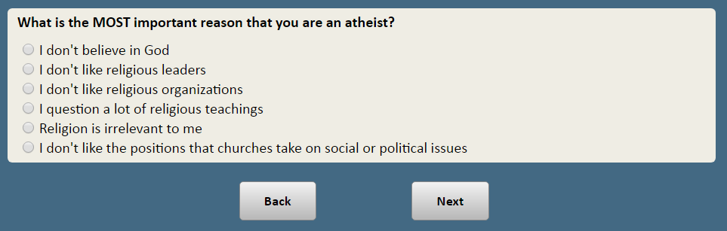

**ASK ALL:**

CHRELIG Thinking about when you were a child, in what religion were you raised, if any?

1 Protestant (for example, Baptist, Methodist, nondenominational, Lutheran, Presbyterian, Pentecostal, Episcopalian, Reformed, Church of Christ, etc.)

2 Roman Catholic

3 Mormon (Church of Jesus Christ of Latter-day Saints or LDS)

4 Orthodox (such as Greek, Russian or some other Orthodox church)

5 Jewish

6 Muslim

7 Buddhist

8 Hindu

9 Atheist

10 Agnostic

11 Something else **[TEXT BOX]**

12 Nothing in particular

*Prompt: You did not specify a response for ''Something else''. If you are sure you want to skip, click Next.*

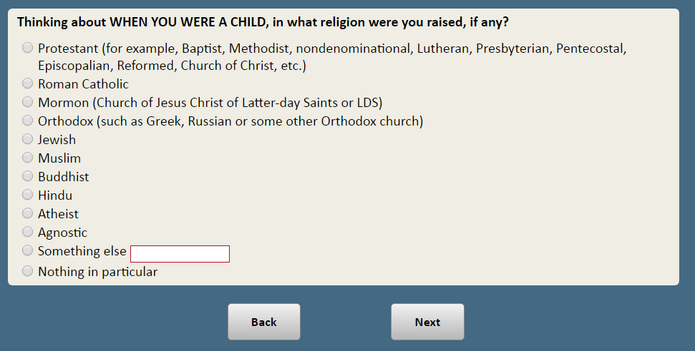

1. Open-end responses are excluded from public datasets to protect the confidentiality of ATP panelists